**Progression of cerebral perfusion and metabolism in neonatal hypoxic-ischaemic encephalopathy**

**G.Balea, N.Taylora, S.Mitrab, I.de Roevera, J.Meek,b N.Robertsonb, I.Tachtsidisa**

*a Medical Physics and Biomedical Engineering, University College London, UK*

*b Institute of Women’s Health, University College London, UK*

*Corresponding author e-mail address: g.bale@ucl.ac.uk*

**Abstract:** Introduction:During hypoxic-ischaemic encephalopathy, there are significant fluctuations in cerebral perfusion as the injury evolves; including hypoperfusion during the latent phase immediately after hypoxia-ischaemia and during therapeutic hypothermia, and hyperperfusion after rewarming1,2.

Methods: We used broadband near-infrared spectroscopy (NIRS) to monitor cerebral blood flow (CBF) and metabolism (via oxidation state of cytochrome-c-oxidase, oxCCO) in 64 term neonates with hypoxic-ischaemic encephalopathy (HIE) in the first days of life3. During monitoring, spontaneous oxygen desaturation events were common. CBF was calculated from the NIRS cerebral oxygenation data (HbD = oxyhaemoglobin - deoxyhaemoglobin) combined with arterial saturation (SpO2) during desaturation events using a method based on Fick’s Law4.

Results: CBF was calculated from 385 eligible events in 47 neonates (see Table 1). Figure 1 shows the weighted mean of CBF in babies with different levels of HIE over the first 5 days of life (therapeutic hypothermia on days 1-3, rewarming on day 4). The CBF was stable (p>0.05) across all days in moderate injury (thalamic Lac/NAA<0.3, n=20). In severe cases of HIE (Lac/NAA≥0.3, n=13), mean CBF was lower on the first day of life compared to moderate cases (p=0.02), and higher on day 5 after rewarming (p=0.04), as expected. Regarding the metabolic changes during these events, in severe cases of HIE there was a larger decrease in oxCCO than in moderate cases (p=0.04)5, indicating metabolic dysfunction in severe injury.

Conclusion: Monitoring cerebral perfusion and metabolism continuously during HIE can potentially assess injury progression and provide prognostic value.

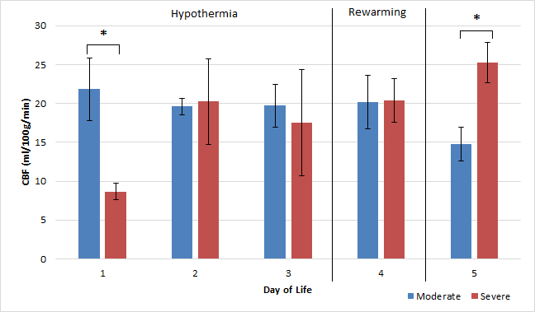

**Table 1:** Number of babies and events per day of life.

**Figure 1:** Average CBF by day of life grouped by injury severity. Error bars show standard error and asterisks denote significant difference between the groups (p<0.05).

**References:** 1. Hassell (2015) Arch Dis Child Fetal Neonatal Ed, 2. Dehaes (2014) J Cerebr Blood Flow Metab, 3. Bale (2014) Biomed Opt Exp, 4. Elwell et al. Adv Exp Med Biol, 5. Bale (in press) J Cerebr Blood Flow Metab

I prefer:  